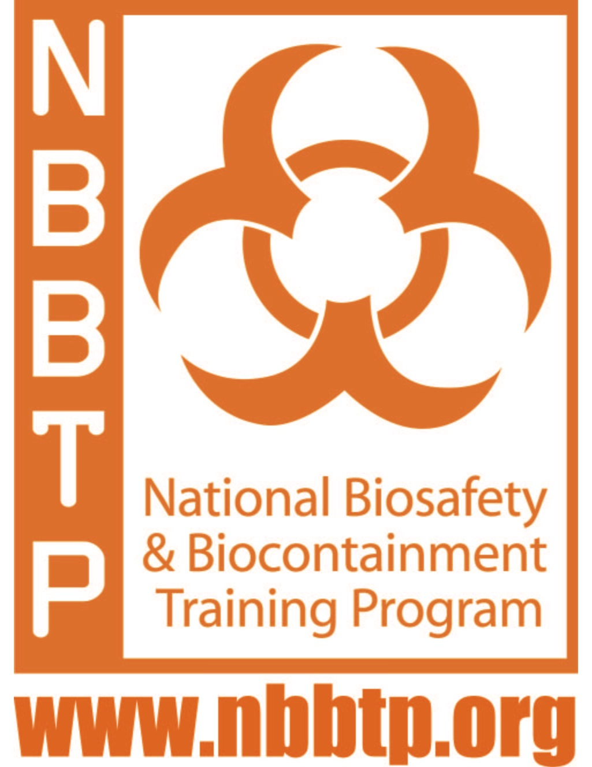
National Biosafety and Biocontainment Training Program (NBBTP)
Intramural Training Research Award (IRTA) Fellowships

The NBBTP IRTA Fellowships are jointly administered by the Division of Occupational Health and Safety (DOHS) and the National Institute of Allergy and Infectious Diseases (NIAID) at the National Institutes of Health. This is a rare opportunity for individuals seeking work in high containment facilities to receive professional training in biosafety and biocontainment at one of the foremost biomedical research centers in the world. Additional information regarding the Fellowships and Professional Development courses is online at www.nbbtp.org; Application packages are due August 3, 2020 for fellowships beginning January 6, 2021 at the NIH Bethesda campus.

The NBBTP Fellowship is designed specifically for people interested in biosafety careers in high containment including facility engineering and maintenance. This is an intensive two-year, immersive experience where Fellows are introduced to all elements of biosafety. The program includes traditional lectures, reading assignments, mentoring projects, applied biosafety research and travel to off-site conferences and training sessions.

Program Eligibility requirements are under review and may be amended. Please check for updates or email info@nbbtp.org to join a notification list in the event these requirements change.

NBBTP IRTA Fellows must be U.S. citizens or permanent residents, be able to pass a Federal background check, and meet all Federal regulations and policies necessary for working with select agents. Applicants must also have:
- Received their bachelor's degree in the Life Sciences (or related fields including plant/agriculture and/or veterinary academic backgrounds or mechanical engineering/facility management) less than three years prior to the January 6, 2021 program start date, or
- Received their master's degree in the above fields less than six months prior to the January 2021 program start date (if they are more than three years post-baccalaureate, or
- Hold a doctoral degree (PhD, MD, DDS, or the equivalent) and no more than five years of relevant research experience since receipt of their most recent doctoral degree.

Fellows must also be willing to relocate to the Bethesda, MD area for two years, and be able to travel to participate in multi-week assignments. Additional eligibility guidelines, including information on English proficiency, are posted online at: http://www.nbbtp.org/policies-and-guidelines/#ProgramEligibility.

How to Apply: Interested applicants must complete the Fellowship Application online at https://nbbtpapplication.org/application/. Resumes/CV’s are required components of the application package. However, applicants who submit resumes/CVs without the additional required application materials will not be considered. All application materials are due by 5:00 pm EST on August 3, 2020 including, resume/CV, official transcripts from the university of your highest degree, and 2020 reference forms (http://www.nbbtp.org/reference-form/).

The NIH is dedicated to building a diverse community in its training and employment programs.
Stipend amounts are based on the NIH IRTA scale.

After the NBBTP: Visit http://www.nbbtp.org/current-nbbtp-fellows/ to meet our current Fellows and discover where our alumni are working at http://www.nbbtp.org/nbbtp-alumni/.

Visit www.nbbtp.org or contact info@nbbtp.org for more information.

