Physical Activity and Neurocognitive Health (PNC) Laboratory
Department of Kinesiology and Community Health, University of Illinois at Urbana-Champaign
Supervised Research Experience Starting Summer and Fall 2022
Applications Close December 1st 2021 at 11:59 pm
Opened to undergraduate students across the UIUC Campus
A minimum commitment of 2 semesters
We can all be simultaneously physically active (think of your daily workout!) and sedentary (all these hours of studying!). May these behaviors affect how we think?
Join us to learn more!
The PNC laboratory, directed by Dr. Dominika Pindus, examines daily physical activity, sedentary behaviors, cognitive and brain functions in children and adults. Students will be involved in delivery of an acute intervention to test the effects of prolonged sitting on cognitive and brain functions in adults.
To learn more visit us at:
http://publish.illinois.edu/physical-activity-and-neurocognitive-health/
We are currently recruiting Undergraduate Research Assistants to help with our projects!
Students can expect to be involved in various duties during their research experience, including:
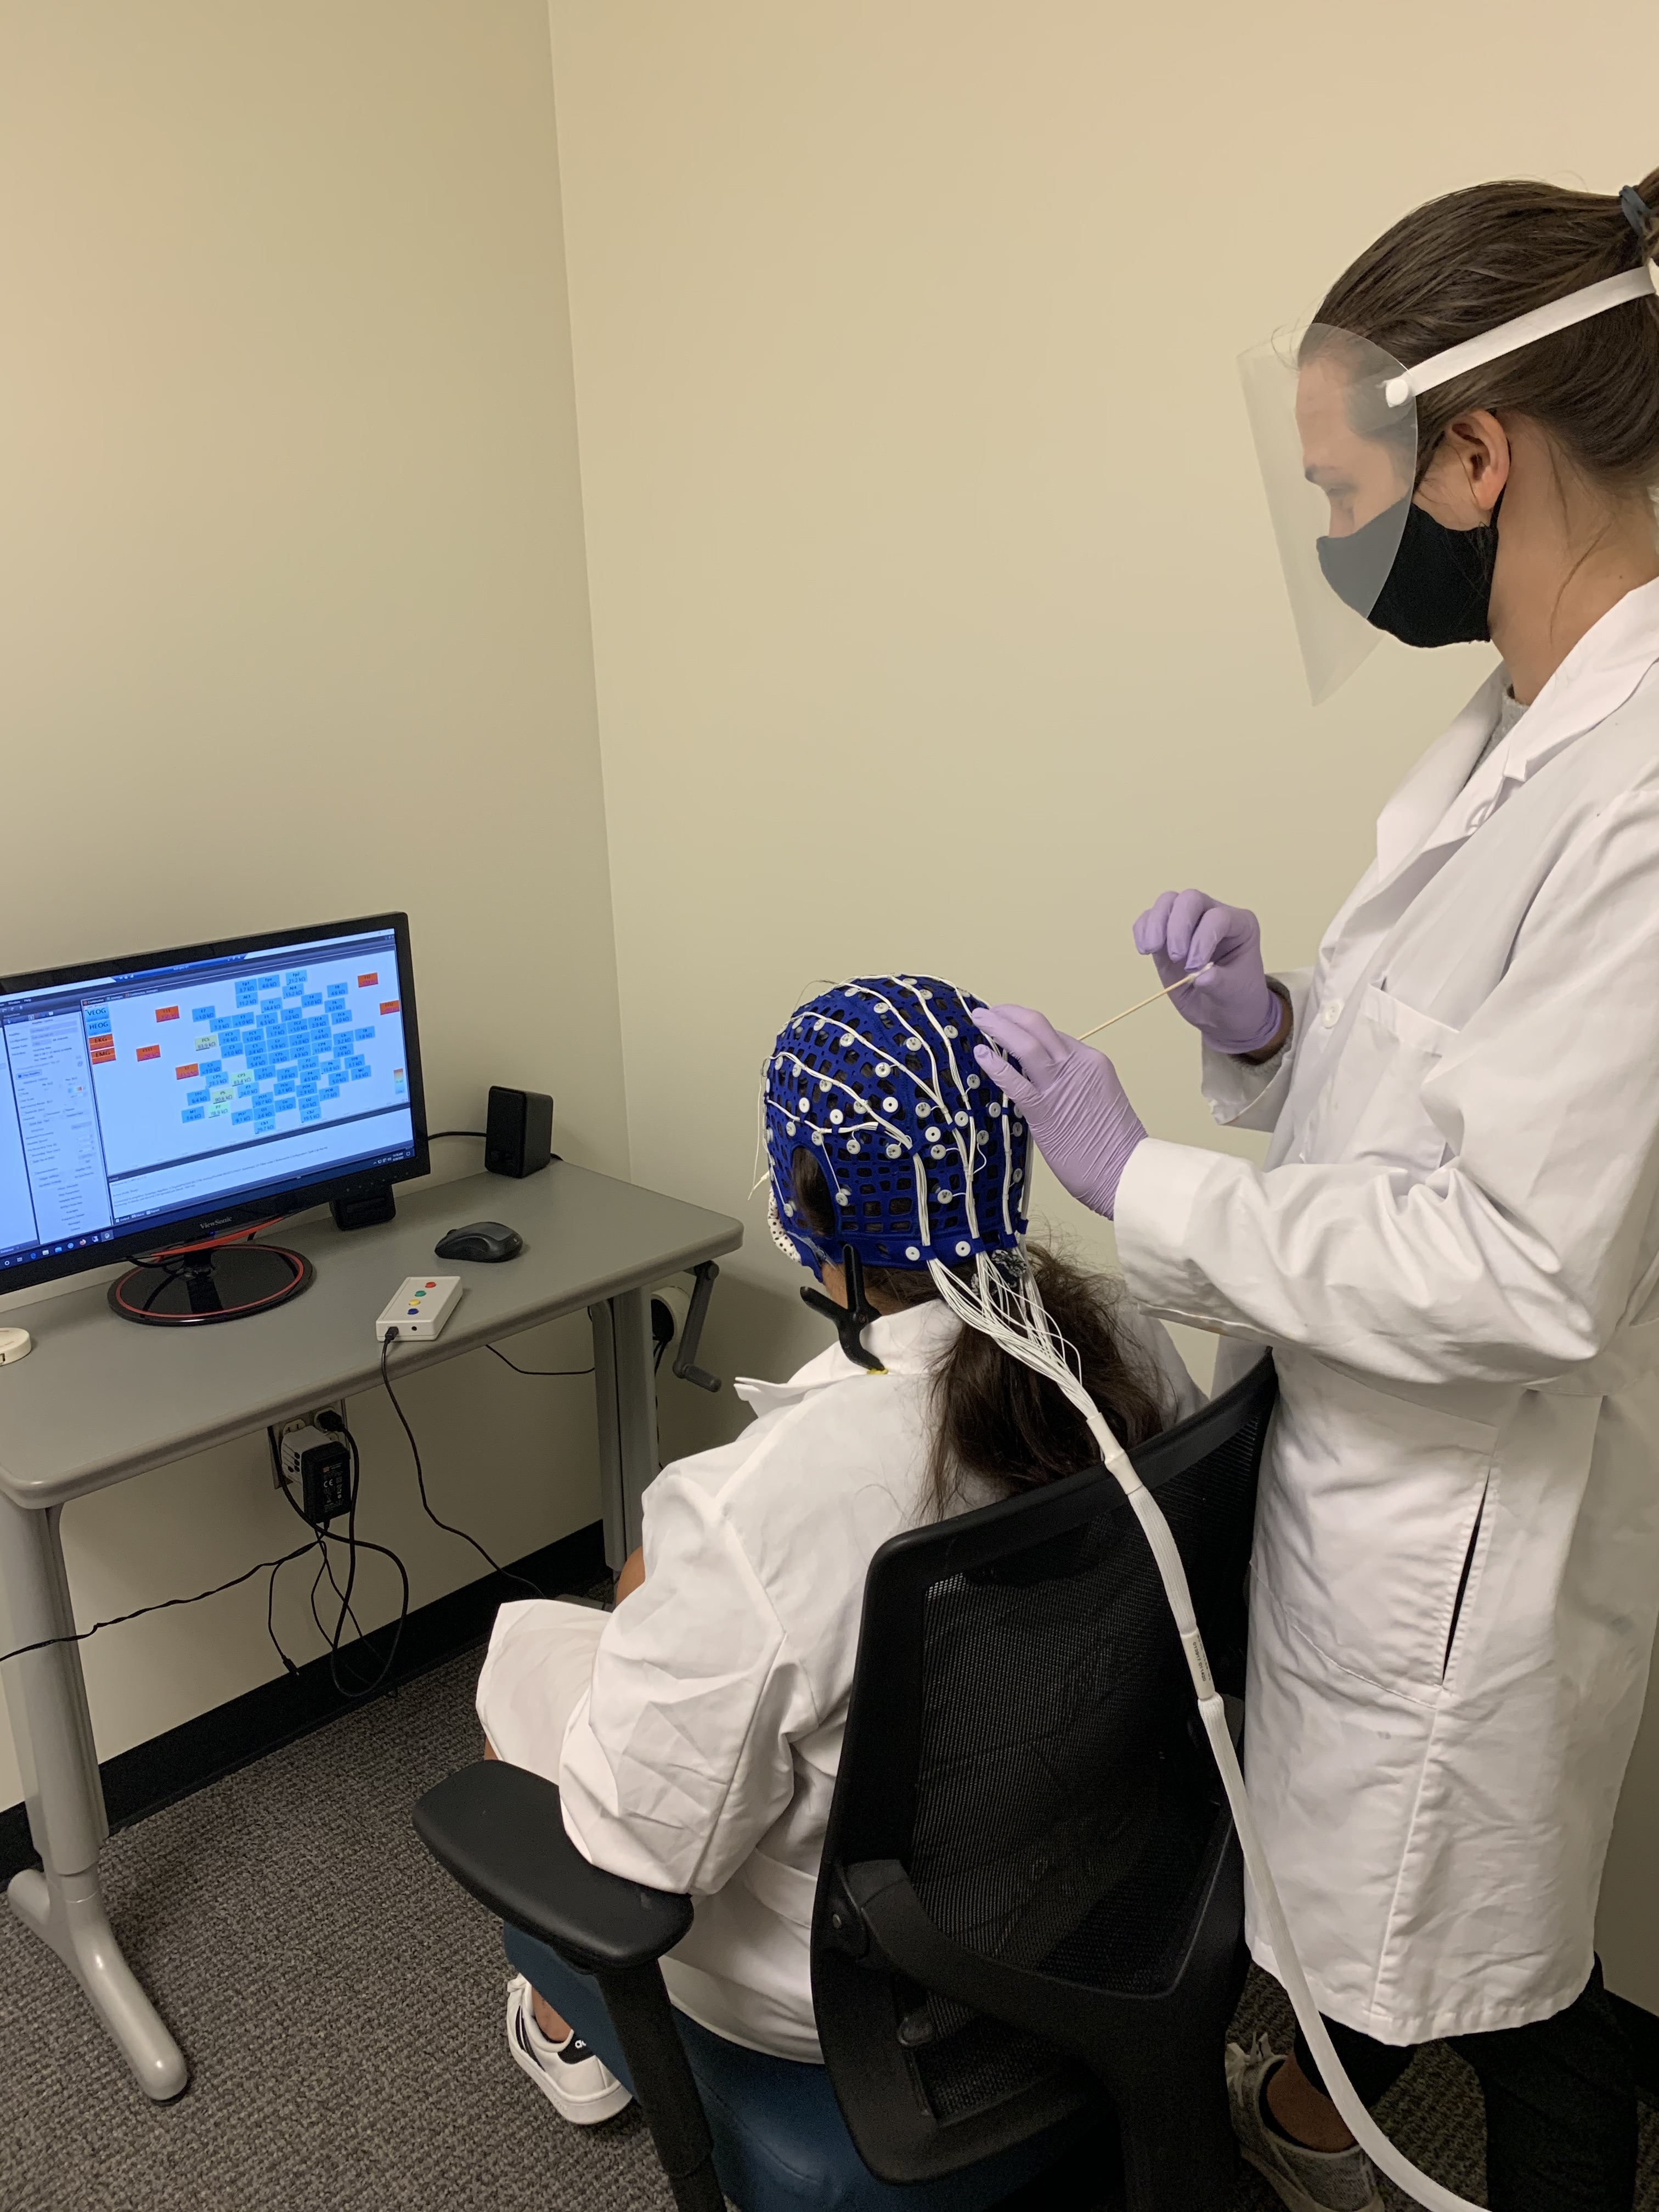
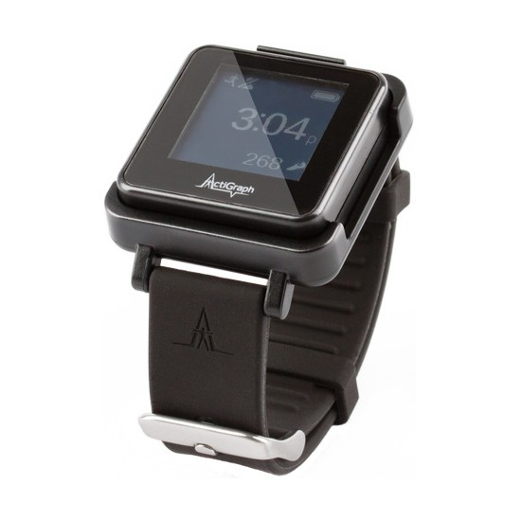
- Participant recruitment and screening
- Preparation of data packages
- Data collection, organization, and processing, including accelerometry and cognitive data processing
- Delivery of physical activity intervention to interrupt prolonged sitting time
- Experience in deployment and data screening using accelerometry and inclinometers
- Experience in administration of neuropsychological tests and computerized cognitive tasks
- Assisting with collection of neurophysiological data (electroencephalography)
- Graded Maximal Exercise Testing
- PNC website updates and social media updates

Visit our website to learn more and apply for this opportunity:
https://forms.gle/bLJtqAoWuyLtge4A9
Required documents
- Your curriculum vitae
- A brief cover letter explaining why you are interested in this research opportunity
- Your class schedule for the semesters which you are applying for

If you have questions, please email Dr. Dominika Pindus: pindus@illinois.edu

